Unit 05 Problem Set Submission Form

# Overview

|  |  |
| --- | --- |
| Your Name | Vinay Kumar Chandra |
| Your SU Email | vchand03@syr.edu |

# Instructions

Put your name and SU email at the top. Answer these questions all from the lab. When asked to include screenshots, please follow the screen shot guidelines from the first lab.

Remember as you complete the problem sets it is not only about getting it right / correct. We will discuss the answers in class so it’s important to articulate anything you would like to contribute to the discussion in your answer:

* If you feel the question is vague, include any assumptions you've made.
* If you feel the answer requires interpretation or justification provide it.
* If you do not know the answer to the question, articulate what you tried and how you are stuck.

This how you receive credit for answering questions which might not be correct.

# Questions

Answer these questions using the problem set submission template. You will need to consult the logical model in the overview section for details. For any screenshots provided, please follow the guidelines for submitting a screenshot.

Write the following as SQL queries. If the query is ambiguous, fill in the gaps yourself and justify your reasoning. For each, include the SQL as a screenshot with the output of the query.

1. The GIS department would like to get a list of latitudes and longitudes of those vBay users who

make valid bids on items and review users also. These are considered active participants in the platform and they would like to plot them on a map for a real-time dashboard.

1. Northwind Traders would like to send out holiday cards to its Employees, Customers and Suppliers. Create a single mailing list from these sources. The mailing address should have 4 lines:   
   0) a label of the source of the address: Employee, Customer, or Supplier
2. customer name and title,
3. company,
4. address, City, Region, Country, postal code

1. vBay would like a list of items with item id name and type along with a count of bids with bid

type (ok, low_bid, item_seller). There should be a column for each of the bid types.

1. Northwind traders has 3 different shippers. For each customer ID and CompanyName list the total amount of shipping freight paid for each of the three different shippers. There should be a column for each shipper.

1. Unpivot all the dates in the Northwind orders table, creating a table output with three columns: order id, type of date (ship date, require date, order date) and the date itself.

1. Unpivot the FudgeFlix titles which are just Movies so that is it easier to query titles which are available in different formats such as instant, DVD, and Blu-ray. Flatten these three columns into a single column with types, but only include a row when the value is 1 in the column.

1. Get a list of the employees from the payroll database as they were on May 31, 2018.

1. Produce a report of Gus Toffwind's pay increases from the payroll database. Include the id, name SSN of the employee along with pay rate, previous pay rate and pay increase (difference between the current and previous pay rates).

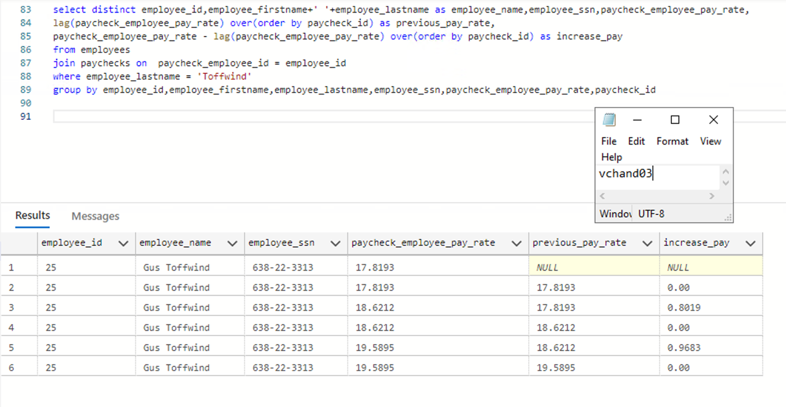

# Reflection

Use this section to reflect on your learning. To achieve the highest grade on the assignment you must be as descriptive and personal as possible with your reflection.

1. What are the key things you learned through the process of completing this assignment?  
     
   Pivot table and Unpivot table are the key things I learned while completing the assignment
2. What were the challenges or roadblocks (if any) you encountered on the way to completing it?

I Didn’t face any challenges

1. Were you prepared for this assignment? What can you do to be better prepared?  
     
   Yes, I was prepared for the assignment
2. Now that you have completed the assignment rate your comfort level with this week’s material. This should be an honest assessment: (choose one)  
     
   4 ==> I understand this material and can explain it to others.